Pokhara University

Level: Bachelor | Semester – Spring | Year : 2007
Programme: BE |  | Full Marks: 100
Course: Filter Design |  | Time : 3hrs.

Candidates are required to give their answers in their own words as far as practicable.
The figures in the margin indicate full marks.

Attempt all the questions.

 | - What is impedance and frequency scaling? List the importance of normalization and denormalization in filter design.  - What do you mean by frequency transformation? What is the significance of frequency transformation? Explain with suitable example. | 8  7
 | - Find the order of the Butterworth filter for the following lowpass filter specification.  - The passband extends form w = 0 to 1000 rad/s.  - The attenuation of the passband should not exceed 0.5 dB.  - The response must give 20 dB attenuation at frequency w = 2000 rad/s  Also show the pole zero location and determine transfer function.  - Derive the expression for transfer function of Sallen-Key low pass biquad circuit. | 10  5
 | - What are doubly terminated and singly terminated LC ladder networks? Realize the third order Butterworth Low pass filter for the signally terminated ladder with R = 1Ω and Z₂₁(s) = K/(S³ + 2S² + 2S + 1) ].  - Design an active filter using inverting Op-Amp configuration with zero at 10, pole at 2 and dc gain of 5. | 8  7
 | - Why sensitivity analysis is necessary in filter design? Drive the transfer function of Two Thomas biquad circuit, and perform its sensitivity analysis.  - Design a switched capacitor filter to realize the requirements of figure overlaid.  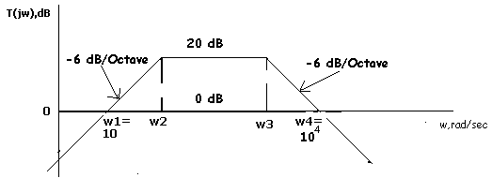 | 8  7
 | - Simulate the following 4th order Butterworth filter with the use of FDNRs such that its cut off frequency is at 1000 Hz and also use 0.01 µF capacitors only.  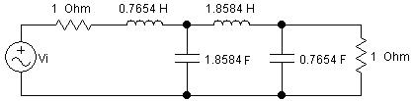  - The magnitude squared function of Chebyshev approximation is: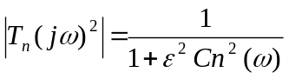 where 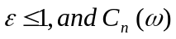 is n^{th} order Chebyshev polynomial.  What are the characteristics of C_{n} 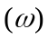? Derive an expression to calculate the order of Chebyshev filter for low pass filter specifications. | 7  8
 | - The following circuit is the highpass filter having normalized cutoff frequency.  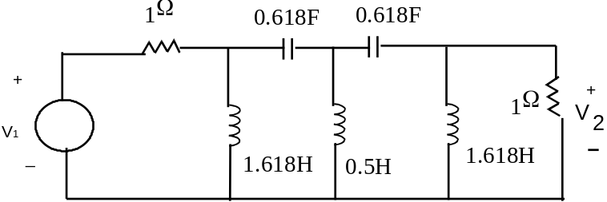  Realize above highpass filter by active simulation of grounded inductors such that the cutoff frequency is 3.4 KHz. Your final circuit should contain the practically realizable element values.  - Design fourth order Butterworth low pass filter having 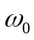 = 5 KHz using Sallen-Key circuit. Perform gain compensation if necessary. Your final circuit should contain practically realizable element values. | 7  8
 | Write short notes on (Any Two):  - Generalize Impedance converter  - Cascade design of filters  - Delay equalization | 2×5
  Order | T (s)
  N = 1 | S + 1
  N = 2 | (s² + √2s + 1)
  N = 3 | (s + 1)(s² + s + 1)
  N = 4 | (s² + 1.8476s + 1) (s² + 0.7654s + 1)
  n = 2 | n = 3 | n = 4 | n = 5 | n = 6
  -0.7071068  ± j 0.7071068 | -0.50  ± j 0.86603 | -0.3826834  ± j 0.9238795 | -0.809017  ± j 0.5877852 | -0.258819  ± j 0.9659258
   | - 1.0 | -0.9238795  ± j 0.3826834 | -0.309017  ± j 0.9510565 | -0.7071068  ± j 0.7071068
   |  |  | - 1.0 | -0.9659258  ± j 0.2588190

